
YEAR 12 CHEMISTRY - ATCHE


SENSORIMOTOR TEST

EQUILIBRIUM

Recommended time: 50 minutes
Total marks

/27

Name: _____________________________________________________

Teacher: _____________________________________________________

The purpose of this experiment is to find out how a system in equilibrium responds to a change in concentration of components in the mixture.

Introduction:

Iron (III) ions and thiocyanate ions react in solution to produce thiocyanatoiron (III), a complex ion, according to the equation:

Fe³⁺_{(aq)} + SCN⁻_{(aq)} ⇄ Fe(SCN)²⁺_{(aq)}
pale yellow colourless blood-red

The colour produced by the complex ion can indicate the position of equilibrium.

Requirements:

Safety glasses 4 test tubes and rack
2 pasteur pipettes distilled water
glass stirring rod spatula
ammonium chloride (NH₄Cl) 50 mL measuring cylinder
iron (III) chloride solution (0.5 molL⁻¹ FeCl₃) 4 x sticky labels
potassiumthiocyaniate solution (0.5molL⁻¹ KSCN)

Procedure: READ AND CARRY OUT THE FOLLOWING PROCEDURES WITH GREAT CARE

1. Mix together one drop of 0.5 molL⁻¹ iron(III) chloride solution and one drop of 0.5 molL⁻¹ potassium thiocyanate solution in a test tube and add 15 mL of distilled water. Record your observations in the Table of Results overleaf.

2. Divide this solution into four equal parts in four test tubes. Label these from 1 to 4.

3. Add one drop of 0.5 molL⁻¹ iron (III) chloride to test tube 1 and shake well.

4. Add one drop of 0.5 molL⁻¹ potassium thiocyanate to test tube 2 and shake well.

5. Add a spatula full of solid ammonium chloride to test tube 3 and shake well.

6. Compare the colours of these solutions with the untouched sample in test tube 4. Enter your observations in the Table of Results overleaf.

Note: At room temperature, ammonium chloride dissociates fully in water according to the equation below:

NH₄Cl_{(S)} → NH₄⁺_{(aq)} + Cl⁻_{(aq)}

The chloride ions react with iron (III) ions in the equilibrium mixture to form the FeCl₄⁻ complex ion.

Fe³⁺ _{(aq)} + 4 Cl⁻_{(aq)} → FeCl₄⁻_{(aq)}

Interpretation of results:

Having made the above observations, complete the table below and then state what can be inferred about the shift in the position of the equilibrium.

Table of Results:

Colour of original sample from procedure step 1. | _{ORANGE / AMBER}
[1 mark]

CHANGE | OBSERVATION  (is the new colour darker or lighter than the original colour in test tube 4) | INFERENCE  (use arrows to show the direction of equilibrium shift, either → or ←)
Tube 1 – adding FeCl₃ | Darker | →
Tube 2 – adding KSCN | Darker | →
Tube 3 – adding NH₄Cl | Lighter | ←
[6 marks]

Complete the concentration vs time graph below showing the variation in concentration of the species Fe³⁺, SCN⁻ and Fe(SCN)²⁺ when the Fe³⁺ is added.

Concentration
of
ions
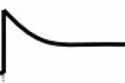
(2)

Fe³⁺

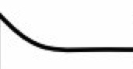
SCN⁻
(1)

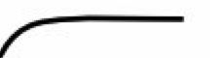
(1)
Fe(SCN)²⁺

time

point at which Fe³⁺ is added point at which equilibrium is re-established [4 marks]

QUESTIONS

1. Would the addition of sodium chloride (NaCl) instead of ammonium chloride to test tube 3 have the same effect as observed? Explain with reference to Le Chatelier’s principle.

Same effect. (1 mark ‘if’ explanation attempted.)

Adding NaCl will decrease [Fe³⁺] in solution due to formation of FeCl₄⁻.
System will favour reverse direction counteract to undo the change. (1 mark)
[2 marks]

2. For the imposed change to test tube 1 (i.e. adding FeCl₃) account for the change in colour using Collision Theory and rates of reaction.

Adding FeCl₃ increases [Fe³⁺] in the solution. (1 mark)
Frequency of collisions between reactants increases. (1 mark)
Initially fwd rate increases, but (1 mark)
at equilibrium both fwd and rev reaction rate increases, but fwd increases more (1 mark)
[Fe(SCN)²⁺] increases hence solution turns darker. (1 mark)
[5 marks]

3. Below is a rate graph obtained by a student for the equilibrium reaction Fe(SCN)²⁺_{(aq)} ⇄ Fe³⁺_{(aq)} + SCN⁻_{(aq)}

The forward reaction is known to be endothermic.

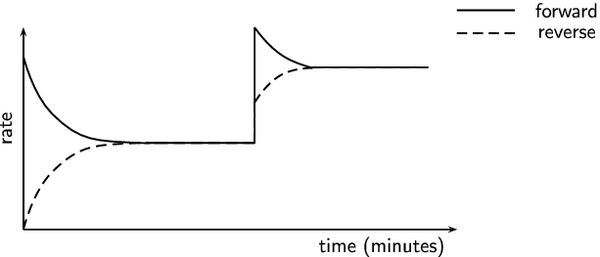
5

(a) State one (1) possible reason for the change observed at the 5-minute mark.

Temperature was increased. (1 mark)
[1 mark]

(b) With reference to the graph and Collision Theory and rates of reaction, explain your answer to part (a) above.

Vertical lines at 5-minute mark show an increase in the rates of both forward and reactions due to an increase in the collision frequency between both reactants and products. (1 mark)

Height difference in the two vertical lines is due to the rate of forward reaction (endothermic) increasing more than the rate of reverse reaction. (1 mark)

[2 marks]

4. Consider a saturated solution of barium hydroxide in contact with solid barium hydroxide:

Ba(OH)_{2 (S)} ⇄ Ba²⁺_{(aq)} + 2OH⁻_{(aq)}

Note that the forward reaction is ENDOTHERMIC.

In each of the following cases, predict whether the equilibrium position would shift to the forward direction (F), shift to the reverse direction (R) or remain unchanged (U).

CHANGE | WRITE ‘F’, ‘R’ or ‘U’
(a) Dilute nitric acid is added | F
(b) Solid barium hydroxide is added | U
(c) A little water is added | F
(d) The temperature of the solution is decreased to a new constant value | R
(0.5 each)

[2 marks]

Consider the following equilibrium:
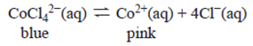

Equal samples of the mixture were heated to two temperatures. The intensity of the pink
colour of the Co²⁺ product was recorded every 30 seconds, the higher the intensity of the pink
colour, the higher the absorbance. The results are shown in the graph:
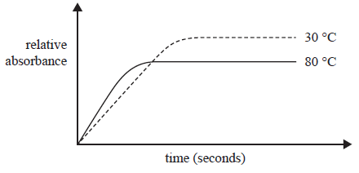

By referring to the graph, determine if the forward reaction is exothermic or endothermic.
(4 marks)
Higher temperature shows less intense pink colour
Indicating the reverse reaction has been favoured
Increasing temperature favours endothermic reaction
Forward reaction is exothermic

